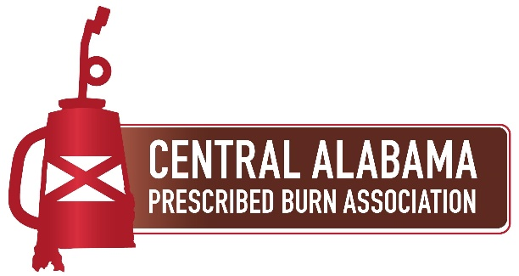
Central Alabama Prescribed Burn Association (CAPBA)
LANDOWNER & PARTICIPANT WAIVER & RELEASE OF LIABILITY

______ (Initial) I hereby warrant that I am at least 18 years old and competent to enter into this agreement. I hereby assume all of the risks of participating in this event, including any risks that may arise from the negligence or carelessness on the part of the persons or entities hosting, sponsoring, or directing this event or any risk from dangerous or defective equipment or property owned, maintained, or controlled by such parties. I certify that I am physically fit, have sufficiently prepared for participation in the event and have not been advised to not participate by a qualified medical professional. I certify that there are no health related reasons or problems which preclude my participation in this event. I certify that I am not under the influence of alcohol or any illicit or prescription drugs which would in any way impair my ability to safely participate in the event or enter into this release and waiver of liability.
______ (Initial) I understand and acknowledge that my participation in this prescribed burning field event is inherently dangerous and represents a test of my physical and mental abilities. I understand and acknowledge that I may suffer minor to serious bodily injury, including loss of life or illness due to smoke inhalation, burns, exposure to field surface hazards & conditions (terrain, vegetation, animals and insects), dangers arising from adverse weather, equipment failure, and/or travel to and from the field site from the staging area. I understand that these risks may be caused in whole or in part by my own actions or inactions or by those of others, and I hereby expressly assume all liability for such risks. I agree to abide by the directions and instructions of the certified burn manager on this event.
______ (Initial) In consideration for allowing me to participate in this event, I hereby release from any and all liability the hosts, sponsors, landowners & instructors of this event from any and all claims of liability arising or resulting from, or in any way connected to, any loss of life, personal or bodily injury or property damage I may suffer in connection with this event, even if caused by the negligent acts or omissions of the those I am releasing. I covenant not to sue and further agree to indemnify, defend and hold harmless the event hosts, sponsors, and instructors, including the property owners, with respect to any liability, claim, demand, cause of action, loss or expense of any kind or nature. I hereby consent to receive medical treatment which may be deemed advisable in the event of my injury, accident or illness. I understand that at this event I may be photographed and agree to allow my photo, video or film likeness to be used for any legitimate purpose by the event sponsors, hosts, or instructors.

This waiver and release shall be construed broadly to the maximum extent permissible under law. I CERTIFY THAT I HAVE READ THIS DOCUMENT; AND I FULLY UNDERSTAND ITS CONTENT. I AM AWARE THAT THIS IS A RELEASE OF LIABILITY BY SIGNING IT.

_____________________________________________ _____________________
NAME (print clearly) DATE
____________________________________________
SIGNATURE

_____________________________________________ _____________________
WITNESS NAME (print clearly) DATE
____________________________________________
WITNESS SIGNATURE

